in today’s lab we are going to be using event viewer to check and see failed login attempts.

backstory

you never know who or what people want access to your personal devices. heck I've had a friend send themselves cash from my phone and delete the message its only when i asked for a mini statement from mpesa is when i discovered that he had done it, thats the first time i felt proper intrusion. now this happened back in 2023 but it got me thinking in the 2010s when smartphones were still new they used to be this apps you could download from the playstore where it would capture failed login attempts and it was fun and most of them failed terribly, how about we recreate that ?. granted in 2026 most pcs don't come with in built cameras and some laptops have the camera lens cover , some use tape . its not a one fits all type of project but my plan is to use event viewer to be able to notify people of failed login attempts when the pc is finally unlocked and to add a pic of the intruder. so lets start the journey

tools

event viewer

so the first thing to do is to access the event viewer with the command win+r and typing in the command eventvwr. msc
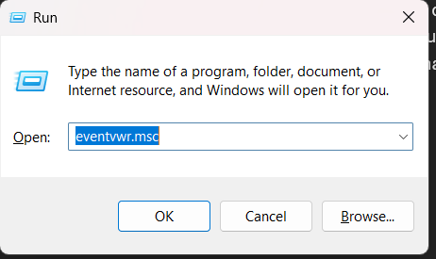

It will look like this 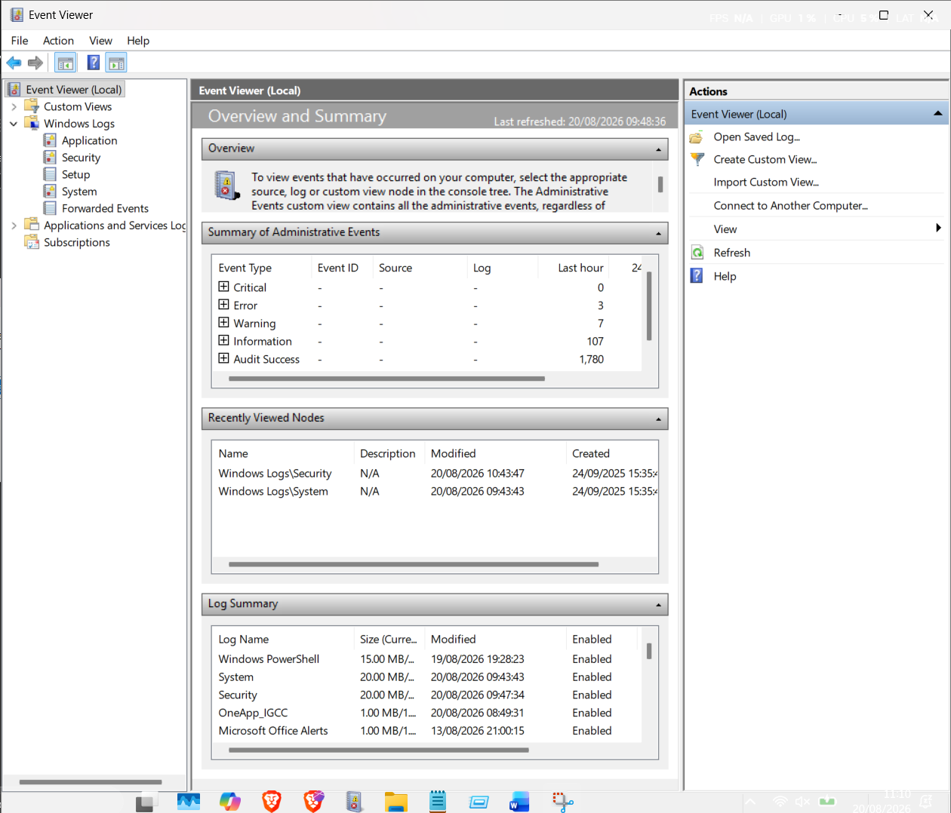

Click on the security and there you will see logs , then navigate to the far right and click filter logs
On the <All Event Ids> replace with 4625, now 4625 is used to show any failed login attempts , 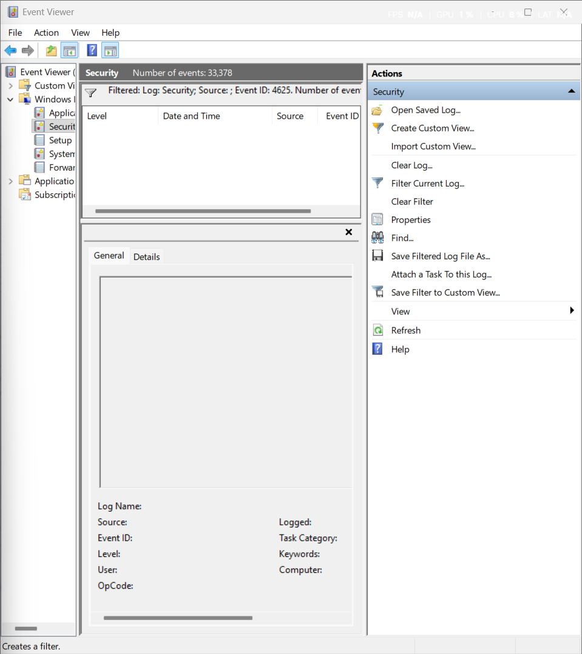
As you can see i dont have any failed login attempts and you can check successful logons by replacing the code in filter current logs section with 4624
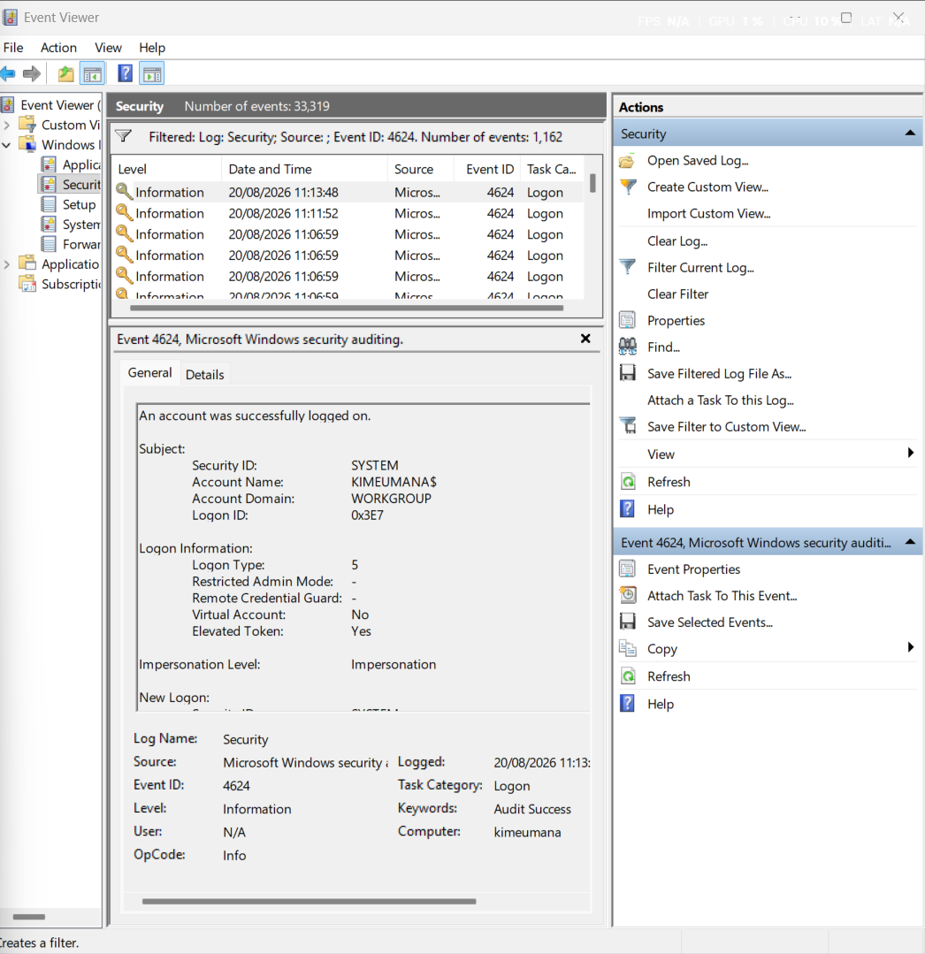
With the image above you can see how many successful logons have occurred from my pc. the event viewer is mostly good to document and do some forensic work on a pc. For example i will lock my pc and attempt to 2 wrong passwords for my pc and see if it registering on the event viewer.

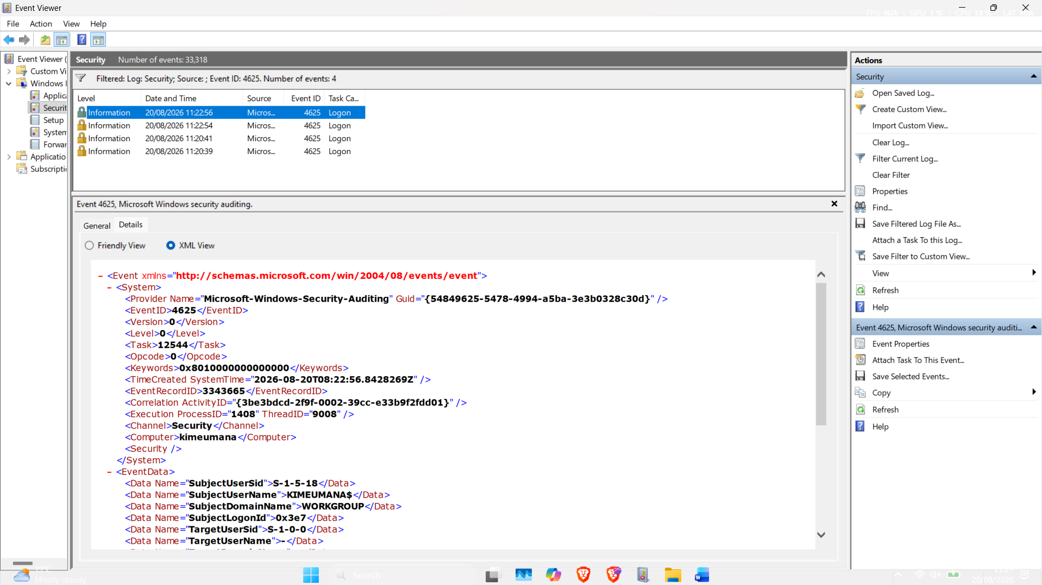

Now the event viewer doesn’t give you much info on the intruder to even the attempted password so with my original idea we are going to see if we can get a solution.

Now we will have to go to PowerShell and run it as admin in order to put in some commands
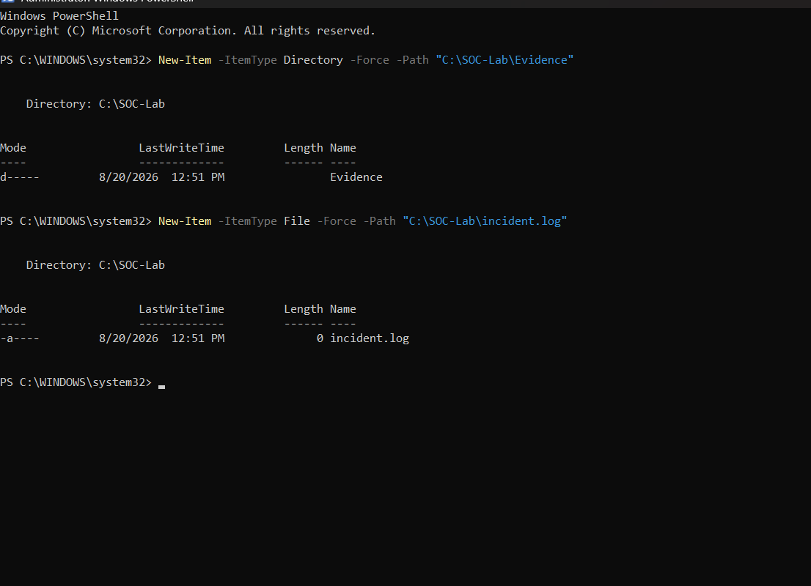
The above commands make folders for storage and where the evidence will be collected
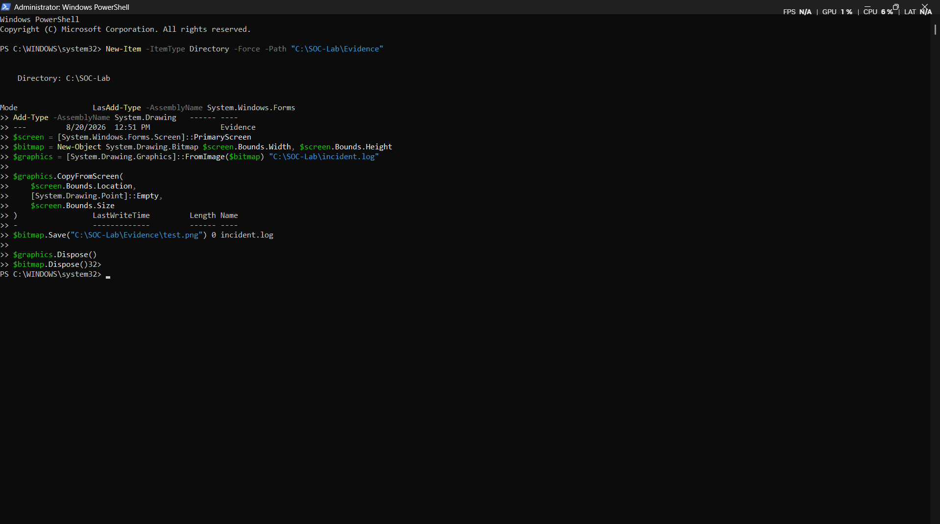
These commands will make it that we can screenshot the screen
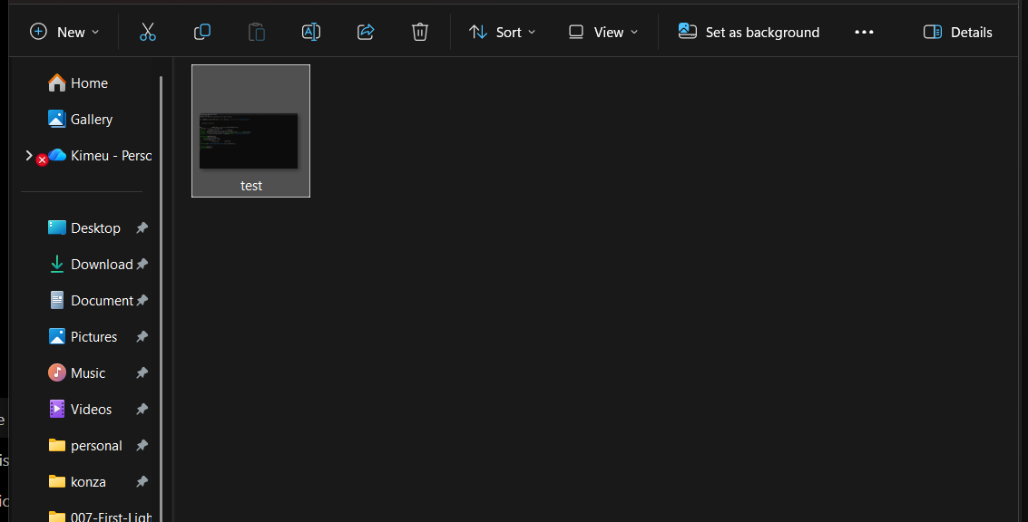
Once you run the command it will show a test screenshot on the evidence folder what a success and the commands below will ensure you get a notification
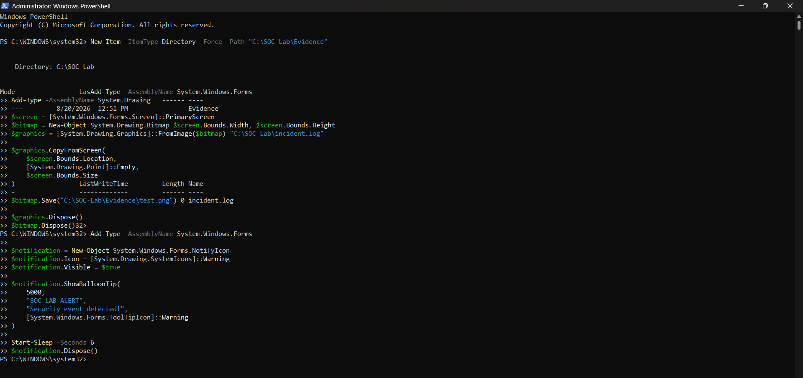
Now lets create the detector
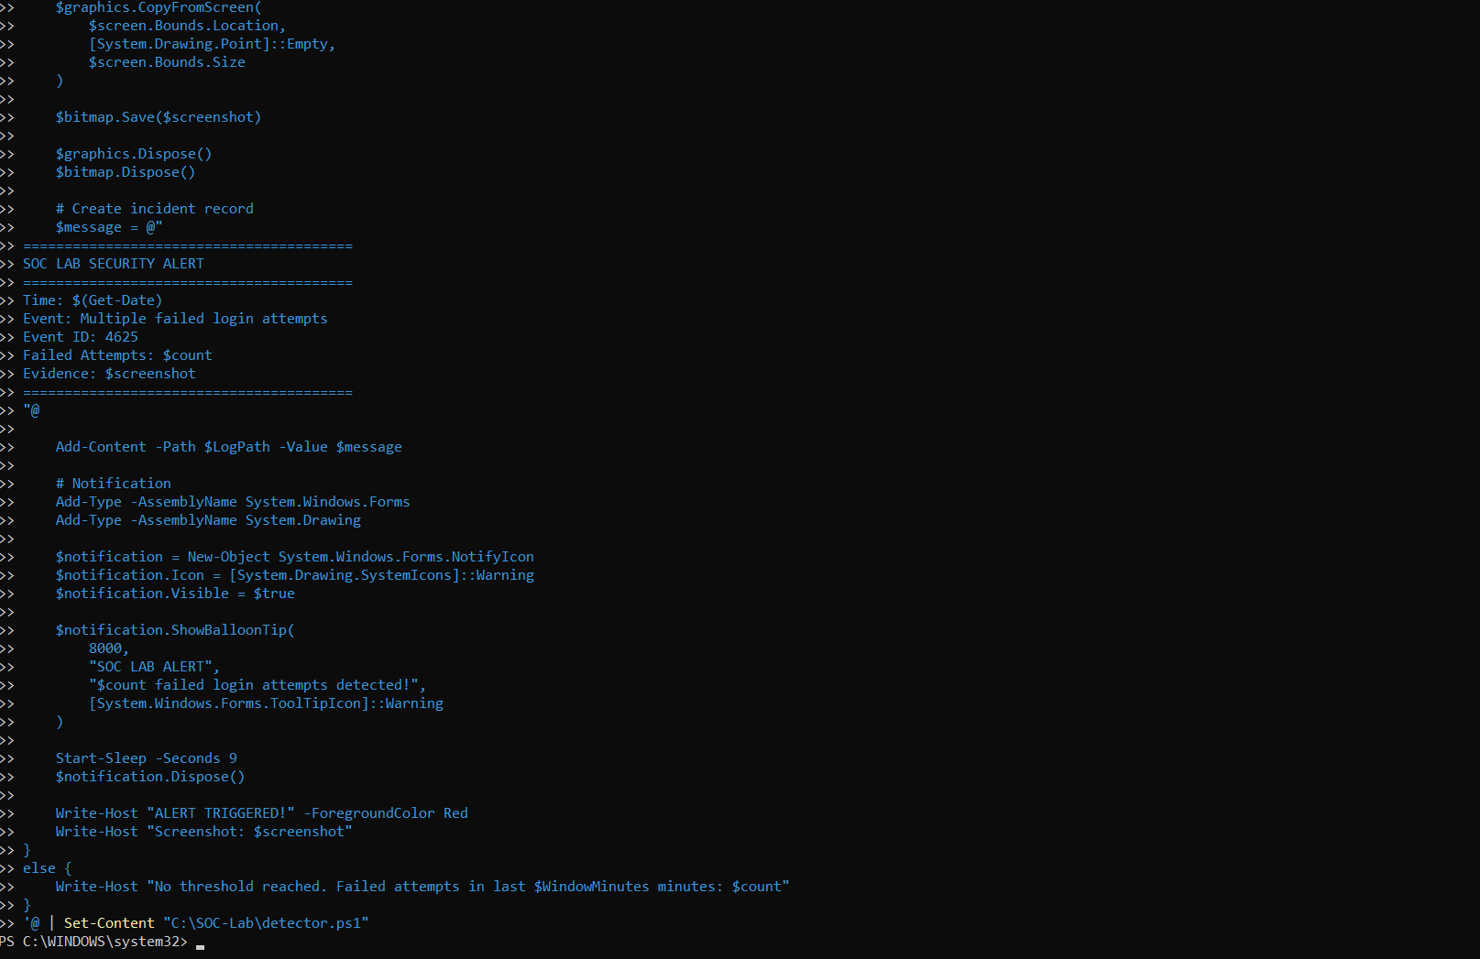
The detector is now live. Ive gone offline and ive just learnt that windows has its own version cause it asked me to input a code shown on the screen to proceed. Anyways below is the detector itself
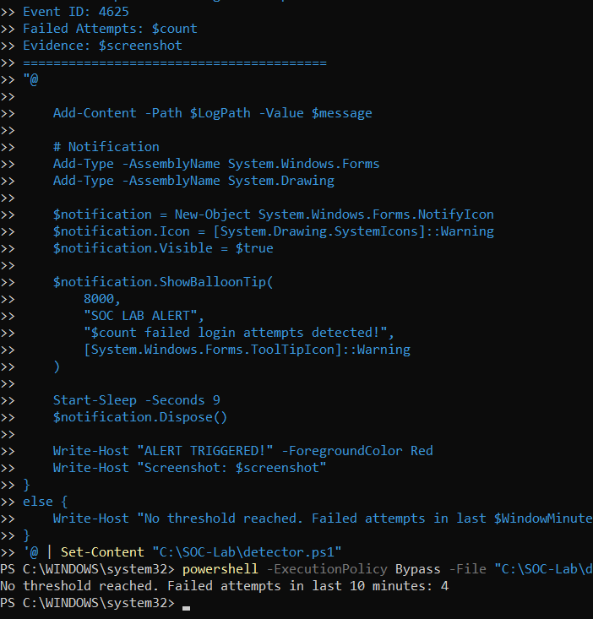
Didn’t meet the threshold but atleast i know it can tell me that someone attempted 4 times . now running this command each time is very boring, lets automate it . we will use task scheduler so as to automatically record the incidents
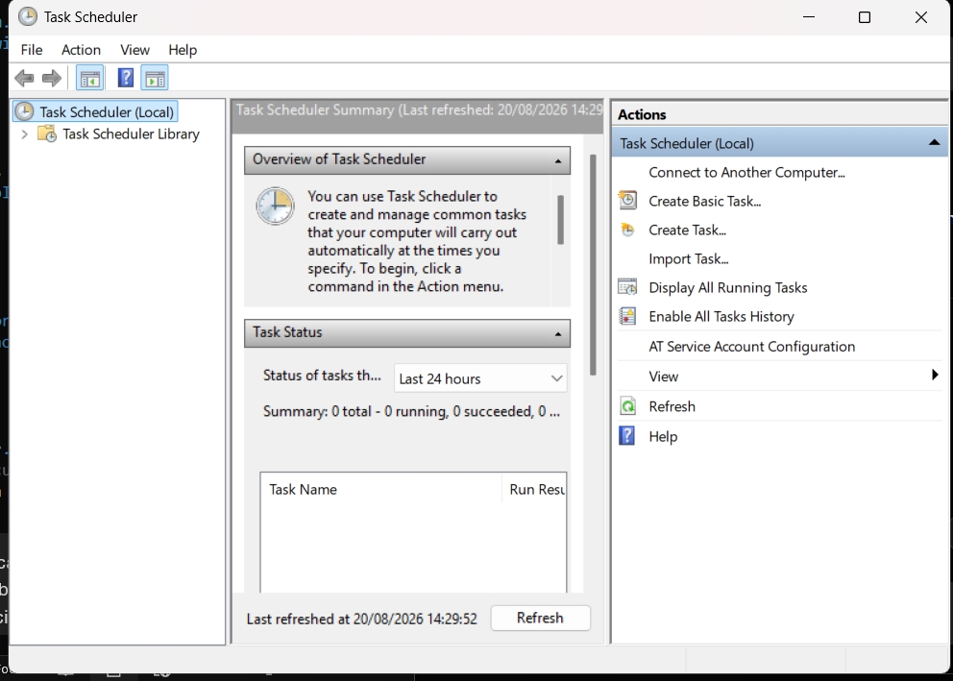
This is task scheduler we will start by creating a task and name it as intrusion detection in general and move to triggers to be a on event trigger
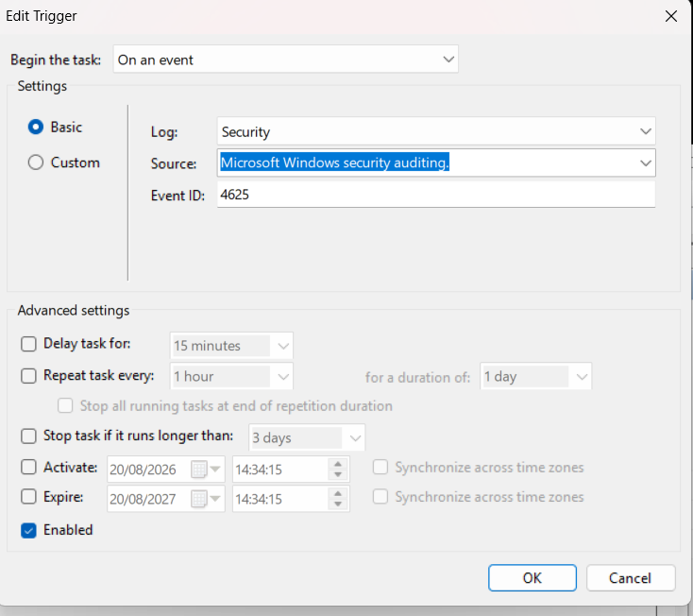

Now we go to the action it will execute our powershell program and the when we allow it. It should be running. Now lets test
NB: maybe also check your pc commands after inputting the pin wrong 5 times it did make me restart good thing i had saved everything

